**Question 1:** Display employee number, lastname, first name and the job description for all the employees. The order of columns for the display must be the same as it is provided in the previous sentence. You will join MSC_employee and MSC_job tables.

* Using a FROM clause in the statement, choose both MSC_Employee and MSC_job tables to select from. In the select statement, include job_description, defining that job_code from the Employee table is equal to the job_code from the Job table. This allows us to map job codes found in Employee to Job Descriptions in the Job Table.

SELECT empl_number, empl_last_name, empl_first_name, job_description

FROM MSC_Employee, MSC_job

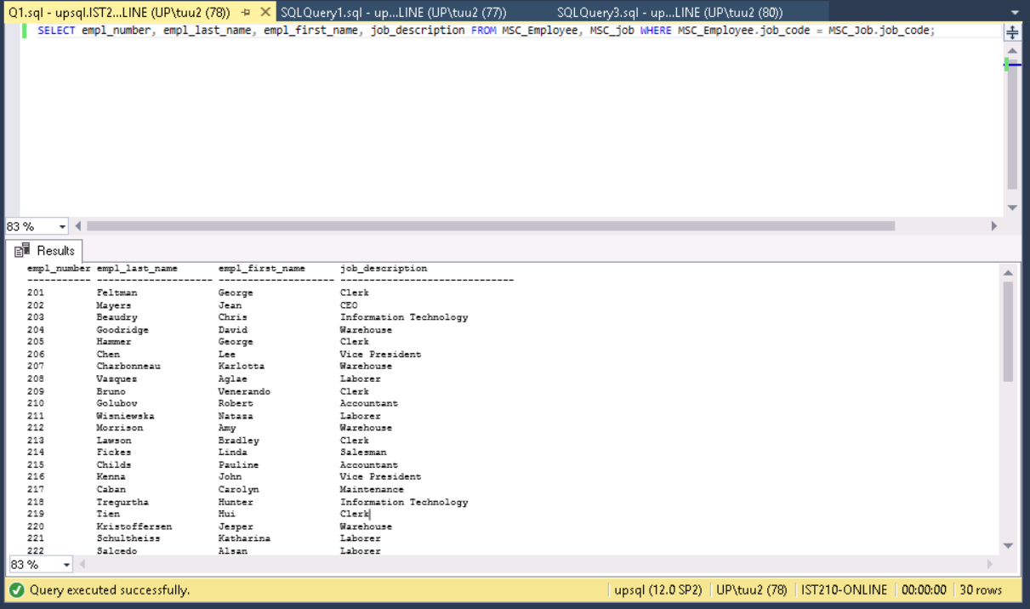WHERE MSC_Employee.job_code = MSC_Job.job_code;

**empl_number empl_last_name empl_first_name job_description**

**----------- -------------------- -------------------- ------------------------------**

**201 Feltman George Clerk**

**202 Mayers Jean CEO**

**203 Beaudry Chris Information Technology**

**204 Goodridge David Warehouse**

**205 Hammer George Clerk**

**206 Chen Lee Vice President**

**207 Charbonneau Karlotta Warehouse**

**208 Vazquez Aglae Laborer**

**209 Bruno Venerando Clerk**

**210 Golubov Robert Accountant**

**211 Wisniewska Nataza Laborer**

**212 Morrison Amy Warehouse**

**213 Lawson Bradley Clerk**

**214 Fickes Linda Salesman**

**215 Childs Pauline Accountant**

**216 Kenna John Vice President**

**217 Caban Carolyn Maintenance**

**218 Tregurtha Hunter Information Technology**

**219 Tien Hui Clerk**

**220 Kristoffersen Jesper Warehouse**

**221 Schultheiss Katharina Laborer**

**222 Salcedo Alsan Laborer**

**223 Rojo Maya Clerk**

**224 Daniel Louise Maintenance**

**225 Jeffries John Salesman**

**226 Brown Bernard Accountant**

**227 Robinson Ralph Clerk**

**228 Moser Alton Laborer**

**229 Cowell Junior Salesman**

**230 Casares Audrea Clerk**

**(30 row(s) affected)**

**Question 2:** Write and execute a SELECT statement that will return the customer’s name, street, state, zip code, salesman’s number assigned to customer, and the assigned salesman’s last name for customers located in the state of Tennessee.

* To display information from both the Customer Table and the Salesman table, use a WHERE statement to find only those rows where the salesman number in the Customer Table is equal to those empl_numbers in the Employee Table. Additionally, isolate only those rows where the Customer is located in Tennessee using the ‘TN’ state code.

*SELECT cust_name, cust_street, cust_state, cust_zip, salesman_number, empl_last_name*

*FROM MSC_Customer, MSC_Employee*

*WHERE MSC_Customer.salesman_number = MSC_Employee.empl_number*

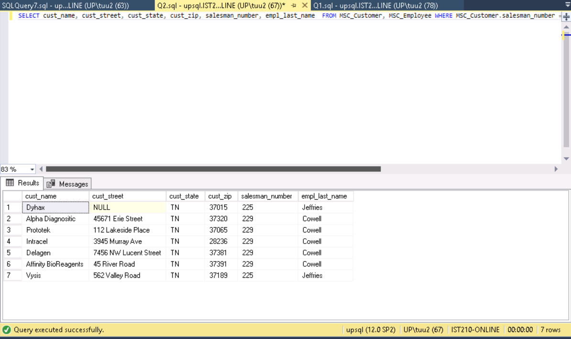*AND cust_state LIKE 'TN';*

cust_name cust_street cust_state cust_zip salesman_number empl_last_name

--------------------------------------------------------------------------------------------------------------

Dyhax NULL TN 37015 225 Jeffries

Alpha Diagnositic 45671 Erie Street TN 37320 229 Cowell

Prototek 112 Lakeside Place TN 37065 229 Cowell

Intracel 3945 Murray Ave TN 28236 229 Cowell

Delagen 7456 NW Lucent Street TN 37381 229 Cowell

Affinity BioReagents 45 River Road TN 37391 229 Cowell

Vysis 562 Valley Road TN 37189 225 Jeffries

(7 row(s) affected)

**Question 3:** Display data from the MSC_Product_detail table by performing a Three Table Join with the MSC_Product_detail, MSC_Product_master and MSC_Vendor tables. The SELECT statement will display product number, product description, commission percent, vendor name and quantity in stock... and only for product details that have quantity in stock less than 200. In addition, the result needs to be sorted by descending value of quantity in stock.

* To get information from MSC_Product_detail, MSC_Product_master and MSC_Vendor, use a FROM statement to SELECT prod_number, prod_description (Product_master), commission_percent, vend_name, and qty_in_stock.
* Make sure to have two clauses under WHERE: MSC_Product_detail = MSC_Product_master AND prod_number qty_in_stock < 200.
* Then, ORDER BY qty_in_stock DESC

SELECT MSC_Product_detail.prod_number, prod_description, commission_percent, vend_name, qty_in_stock

FROM MSC_Product_detail, MSC_Product_master, MSC_Vendor

WHERE MSC_Product_detail.prod_number = MSC_Product_master.prod_number AND MSC_Product_detail.vend_number = MSC_Vendor.vend_number AND qty_in_stock<200

ORDER BY qty_in_stock DESC;

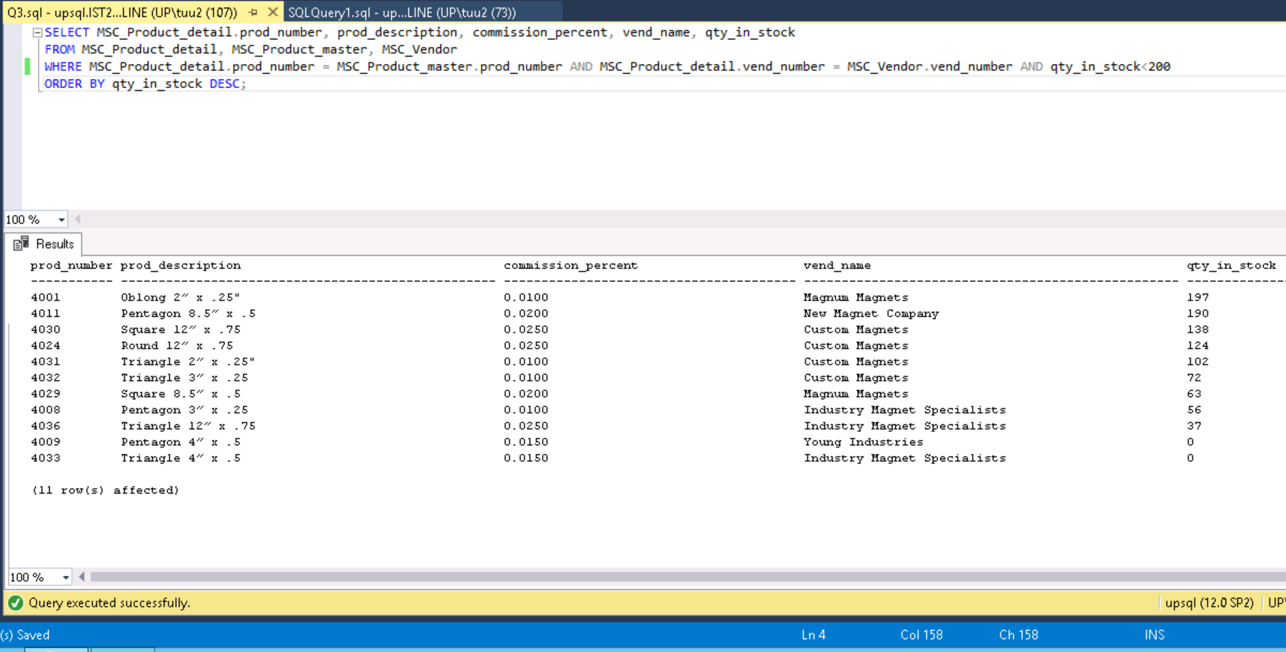

*prod_number prod_description commission_percent vend_name qty_in_stock*

*----------- -------------------------------------------------- -----------------------------------------------------*

*4001 Oblong 2? x .25" 0.0100 Magnum Magnets 197*

*4011 Pentagon 8.5? x .5 0.0200 New Magnet Company 190*

*4030 Square 12? x .75 0.0250 Custom Magnets 138*

*4024 Round 12? x .75 0.0250 Custom Magnets 124*

*4031 Triangle 2? x .25" 0.0100 Custom Magnets 102*

*4032 Triangle 3? x .25 0.0100 Custom Magnets 72*

*4029 Square 8.5? x .5 0.0200 Magnum Magnets 63*

*4008 Pentagon 3? x .25 0.0100 Industry Magnet Specialists 56*

*4036 Triangle 12? x .75 0.0250 Industry Magnet Specialists 37*

*4009 Pentagon 4? x .5 0.0150 Young Industries 0*

*4033 Triangle 4? x .5 0.0150 Industry Magnet Specialists 0*

*(11 row(s) affected)*

**Question 4:** Write a select statement that will display customer number, customer name and the number of orders belong to the customer whose state is South Carolina. You will need to join two tables, use a COUNT aggregate and a GROUP BY clause in your SELECT statement. Override labels with a more descriptive but brief label.

* Display cust_num, cust_name, and their number of orders using count(ord_number), making sure to include FROM MSC_Order and MSC_Customer tables in the query. For each column in the select statement, alias the labels using AS statements.
* Use WHERE statement to specify that only those Customers with addresses with cust_state=”SC’ (South Carolina)
* Then utilize a GROUP BY statement to sort the rows by the customer’s name and by their customer number.

*SELECT MSC_Customer.cust_number as "Customer Number", MSC_Customer.cust_name as "Customer Name", count(ord_number) as "Number of Orders"*

*FROM MSC_Order, MSC_Customer*

*WHERE MSC_Customer.cust_state='SC'*

*GROUP BY MSC_Customer.cust_name, MSC_Customer.cust_number;*

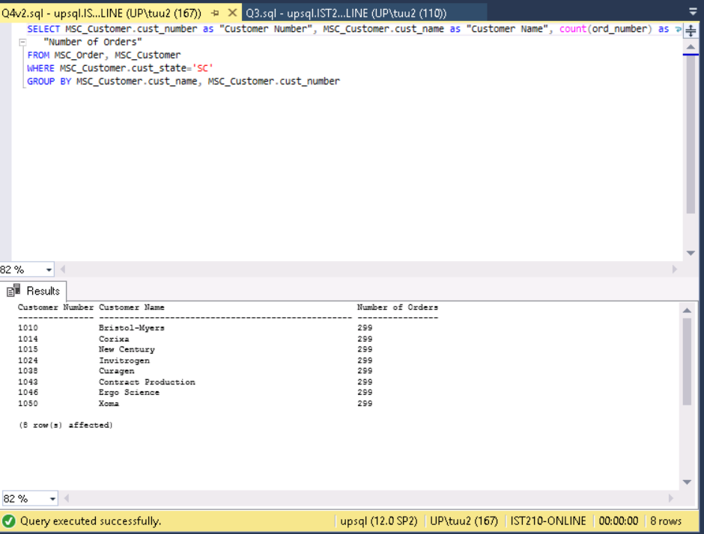

Customer Number Customer Name Number of Orders

--------------------------------------------------------------------------------

1010 Bristol-Myers 299

1014 Corixa 299

1015 New Century 299

1024 Invitrogen 299

1038 Curagen 299

1043 Contract Production 299

1046 Ergo Science 299

1050 Xoma 299

(8 row(s) affected)

**Question 5:** Create and execute a SELECT statement that would provide data for a vendor directory. Display should include vendor number, vendor name, street, city, state, zip code. Concatenate the address elements to look like ‘1234 Main Street State College, PA 16802’. Override the column labels with meaningful descriptions. Directory display should be sorted by zip code of vendor.

* Displaying formatted data about Vendors found in MSC_Vendor, you have to display important information such as the vend_number, vendor_name, and components of their address. To put all pieces of address together, use the concat statement to put together street, city, state, and zip into one column. To improve visual display, use the AS operator to alias those selected columns to headers like ‘Vendor Number’, ‘Vendor Name’, and ‘Vendor Address’
* Afterwards, make sure to use ORDER BY ASC to sort findings by vendor’s zip code in ascending order.

*SELECT vend_number as "Vendor Number", vend_name as "Vendor Name", concat(vend_street, ' ', vend_city, ', ', vend_state, ' ' , vend_zip) as "Vendor Address"*

*FROM MSC_Vendor*

*ORDER BY vend_zip ASC;*

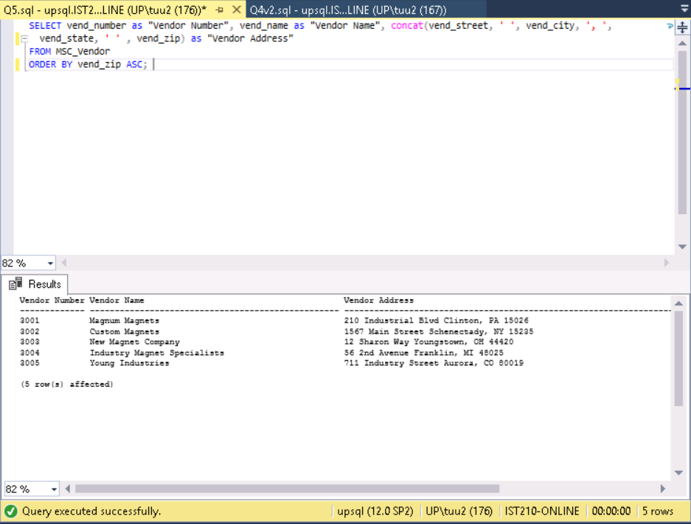

*[Rows Affected on next page]*

Vendor Number Vendor Name Vendor Address

------------- -------------------------------------------------- ---------------------------------------------------

3001 Magnum Magnets 210 Industrial Blvd Clinton, PA 15026

3002 Custom Magnets 1567 Main Street Schenectady, NY 15235

3003 New Magnet Company 12 Sharon Way Youngstown, OH 44420

3004 Industry Magnet Specialists 56 2nd Avenue Franklin, MI 48025

3005 Young Industries 711 Industry Street Aurora, CO 80019

(5 row(s) affected)